Ebike Display/Controller

Ryan Friedman

Todo:

Increase ID of twist throttle by 0.35mm without increasing outer thickness, add large base fillet

Move light mount screws apart a tiny bit

Decrease key screw distance from key center axis by 0.5mm

Make key cover

Change LCD font size

Current electric bikes are subject to power limitations. In the US, E-bikes are limited to 750W. By installing a 3rd party motor and controller on a normal bike, this power requirement can be surpassed. However, many of the inexpensive kits are hard to install, aren’t tunable, and lack necessary features. The systems are not integrated, and while the sensors and data largely exist to improve the controller, none of the systems are designed to integrate well.

The goal of this project is to integrate the motor, speed controller, shifter, and throttle control into a single controller. User feedback will be provided via a screen, and configuration will be possible either through a menu on the screen, phone application utilizing a USB OTG cable, or a laptop with program.

Specifically, the Cyclone motor and half-twist throttle, sold by Luna cycle, are the centerpiece of the hardware. At a high level, the twist throttle contains a key ignition to turn on the controller. The throttle sends an analog voltage to the motor, which is proportional to the speed. The throttle also features a dim LED indicator for the voltage, but it is not accurate. Another downside is that the key ignition is in the way of the rear shifter, so the rider needs to remove their hand from the bars to shift.

By communicating with the speed controller, reading the raw throttle values, and commanding the shifting, a current-based PID control can be implemented to provide a smoother and more natural motor response. More useful data metrics can be supplied to the rider via a new display, and electronic shifting will aid the motor in achieving optimum efficiency and RPM if implemented. Safety can be improved by preventing large increases in motor speed at low riding speed. Safety will also be improved through current limits, a minimum battery voltage, and increased waterproofing of the electronics.

* Physical
  + Water Resistant
  + Improve Ergonomics of twist throttle
    - Move key ignition to above the brake
  + Add-on lights
    - Front lights, adjustable brightness via PWM
    - Maybe multicolor?
* Electrical
  + Adjust speed line
    - Smooth from quick changes
    - Add expo to make low end more sensitive
  + Bright Voltage Display
  + 3 button interface
    - Up, down, select(short)&(long)
* Parts:
  + 3D printed case
  + M3 screws
  + Light 3D print mounts
  + Circuity main components:
    - Nokia Display
    - 3 nav buttons, emergency stop
    - 72V voltage regulator
    - Buzzer
  + Extensions
    - Lights
    - Servo shifting
      * Servo
      * 3D printed cable holder
      * Large tactile buttons
      * motor speed crawl when shifting?
    - Brake cutoff?

References:

Ebike Parts:

Voltage reg: Max5035

https://datasheets.maximintegrated.com/en/ds/MAX5035.pdf

-> Needs application circuit shown

<https://www.digikey.com/products/en/integrated-circuits-ics/pmic-voltage-regulators-dc-dc-switching-regulators/739?FV=a4027c%2C8f40069%2C8f40087%2C8f400a7%2C8f40011%2C8f400ab%2C8f400da%2C8f400db%2C8f400e3%2C8f4012c%2C8f40021%2Cffe002e3%2C1bcc0145&quantity=0&ColumnSort=1000011&page=1&pageSize=25>

Nokia 5110 image:

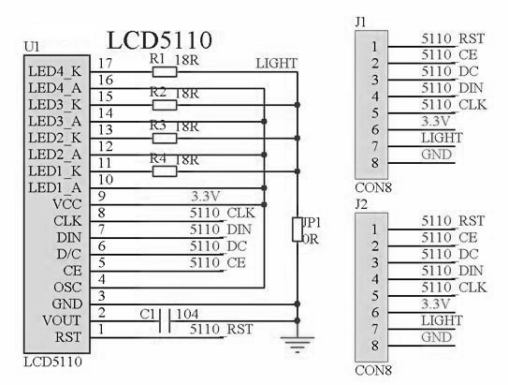

* Add balance pot to adjust light, or a jumper

Source for adding Arduino shield:

<https://www.youtube.com/watch?v=9KQxZM6MeHA>

Current Sensing:

Current sense IC: INA 169 (high side) or INA 199 (low side)

<http://www.ti.com/product/INA199/technicaldocuments>

Note: Using INA 2xx series with 16 bit ADC may result in best PID performance at expense of increased cost.

